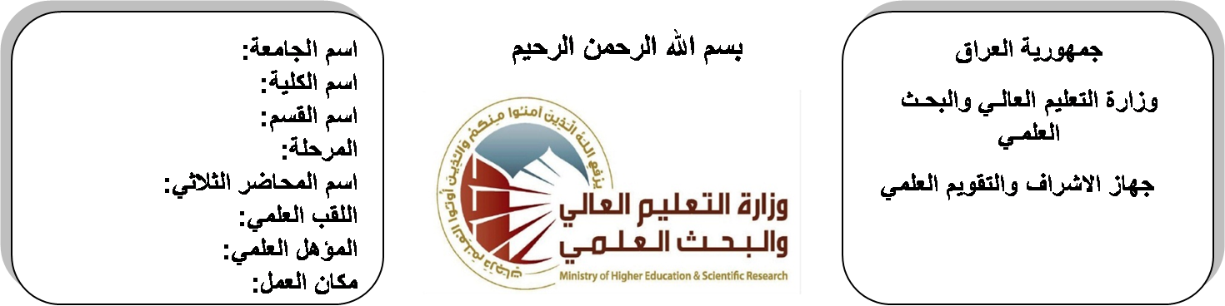

**Republic of Iraq**

**Ministry of Higher Education**

**& Scientific Research**

**University: Diyala University**

**College: College of Engineering**

**Department: Electronic Engineering**

**Stage: second**

**Lecturer name:Hassan saadullah**

**Qualification: M.Sc**

**Place of work: Electronic Dept.**

**(( Annual teaching plan form))**

|  |  |  |  |  |
| --- | --- | --- | --- | --- |
| **Lecturer Name** | **Hassan Saadullah Naji** | | | |
| **Email** | **Hassan_sn@yahoo.com.** | | | |
| **Subject** | Electromagnetic Fields | | | |
| **Aims** | **The aim of this subject is to make the students ready to undestand and comprehend the scientific theories and their applications related to their field of the study.** | | | |
| **Textbooks** | ***Engineering Electromagnetics***  ***Sixth Edition***  ***William H. Hayt, Jr. . John A. Buck*** | | | |
| **Additional Textbooks** |  | | | |
| **Assessments** | **First Semester** | **Second Semester** | **Laboratory** | **Final Exam** |
| 20% | 20% |  | 60% |
| **Notes** |  | | | |

**Schedule Weekly Lessons - First Semester**

|  |  |  |  |  |
| --- | --- | --- | --- | --- |
| **Week** | **Date** | **Lectures** | **Lab. Experments** | **Notes** |
| 1 | **30/9/** | The Cartesian coordinate system ,vector components and unit |  |  |
| 2 | **7/10/** | vector field dot product, cross product, circular cylindrical coordinate system, spherical coordinate system |  |  |
| 3 | **14/10/** | Coulombs law and electric field intensity-filed of n point charge |  |  |
| 4 | **21/10/** | field due to continuous volume charge distribution |  |  |
| 5 | **28/10/** | field of line charge. Field of sheet of charge , streamline and sketches of fields , electric flux density. |  |  |
| 6 | **4/11/** | Electric flux density , gauss law–application of gauss law |  |  |
| 7 | **11/11/** | differential volume element–divergence , Maxwell first equation. |  |  |
| 8 | **18/11/** | Energy & potential energy expended in moving appoint charge |  |  |
| 9 | **25/11/** | the line integral- definition of potential difference &potential, the potential field of point charge the potential field of system charge |  |  |
| 10 | **2/12/** | Conservative property, potential gradient. The dipole. |  |  |
| 11 | **9/12/** | Conductors, dielectrics & capacitance. Current &current density |  |  |
| 12 | **16/12/** | , continuity of current metallic conductors. Conductor properties &boundary condition |  |  |
| 13 | **23/12/** | method of image semiconductors . Nature of dielectric material |  |  |
| 14 | **30/12/** | Poisson &lap lace equation . examples of the solution of lap lace equation (1-D) , examples of the solution of Poisson's equation (1-D) |  |  |
| 15 | **6/1/** | Boit-savart law , amperes circulate . Curl stokes theorem. Magnetic flux & magnetic flux density |  |  |
| Half Year holiday | 15/1/ to  1/2/ |  |  |  |

**Lecturer Signature Head of Dept. Signature Dean Signature**

**Schedule Weekly Lessons - Second Semester**

|  |  |  |  |  |
| --- | --- | --- | --- | --- |
| **Week** | **Date** | **Lectures** | **Lab. Experments** | **Notes** |
| 1 | **17/2/** | Boit-savart law , amperes circulate . Curl stokes theorem. Magnetic flux & magnetic flux density |  |  |
| 2 | **24/2/** | Derivation of steady – magnetic field laws |  |  |
| 3 | **2/3/** | magnetic forces |  |  |
| 4 | **9/3/** | Force on moving charge |  |  |
| 5 | **16/3/** | force on differential current element |  |  |
| 6 | **23/3/** | force between differential current elements |  |  |
| 7 | **30/3/** | force and torque and torque on a closed circuit |  |  |
| 8 | **6/4/** | Magnetization and permeability |  |  |
| 9 | **13/4/** | Magnetization and permeability |  |  |
| 10 | **20/4/** | magnetic boundary condition |  |  |
| 11 | **27/4/** | the magnetic boundary condition |  |  |
| 12 | **4/5/** | the magnetic circuit |  |  |
| 13 | **11/5/** | potential energy |  |  |
| 14 | **19/5/** | force on magnetic materials |  |  |
| 15 | **26/5/** | force on magnetic materials |  |  |
| 16 | **3/6/** | inductance and mutual inductance |  |  |

**Lecturer Signature Head of Dept. Signature Dean Signature**